

________________________________________________________________
DESIGN AND DEVELOPMENT OF AN INTERACTIVE UNIVERSITY COURSE REGISTRATION PORTAL

Scenario Based Assignment

Course Code: ITA0201
Course Name: WEB TECHNOLOGY
Student Name: N.Keerthikaa, S.Pragathi Bai
Register Number: 192521064, 192521069
Department: B.Tech.IT, B.Tech IT

1. INTRODUCTION:
Modern web technologies have brought significant changes in the field of education and management of academic activities. Educational institutions use web-based applications to manage registration, examination, attendance, and academic information of the students.
A student needs to view the available courses, know course information, choose appropriate subjects, and submit his/her registration information.
The Interactive University Course Registration Portal is designed as a simple web-based application which provides students with an organized platform to view available courses and submit their registration details. The system shows information about the university courses and allows students to select one or more subjects according to their requirements.
The portal is developed using HTML/XHTML, CSS, and JavaScript. HTML/XHTML is used to create the structure and content of the webpage. CSS is used to create professional and attractive UI. JavaScript is used to create client-side interactions, validate user inputs, store selected course information, calculate total credits, and generate the registration summary dynamically.
The project also covers important concepts from Unit I and Unit II, such as HTML/XHTML structure, navigation, tables, lists, hyperlinks, forms, CSS selectors, box model, Flexbox or Grid layout, responsive design, JavaScript arrays, objects, functions, validation, DOM manipulation, and debugging.
The proposed Course Registration Portal provides an illustrative example of how modern web technologies can be used to build interactive academic application.

2. PROBLEM STATEMENT:
An educational institution offers various courses for students in each academic semester. A student needs to know the available courses and select subjects according to the department and his/her academic requirements.
In the manual registration process, course information may be provided in printed notices or manual forms. Students may need to fill in the form manually, select subjects, and submit the filled-in form for further processing.
Such approach may create several difficulties such as:
- Difficulty in organizing course information;
- Errors in entering student details;
- Selection of invalid or incorrect courses;
- Lack of immediate validation;
- Difficulty in calculating the total number of selected courses;
- Errors in calculating total course credits;
- Time-consuming process;
- Lack of an interactive registration experience.
There is a necessity for a simple web-based Course Registration Portal which can provide organized course information and allow students to submit their registration details.
The proposed system solves above-mentioned issues by providing an interactive webpage where students can view courses, select courses, enter their personal and academic information, and receive an immediate registration summary.
The system validates the entered information before processing the registration. Also, it calculates the total number of selected courses and total credits automatically.

3. OBJECTIVES OF THE PROJECT:
The main objective of the project is to design and develop a responsive and interactive University Course Registration Portal using client-side web technologies.
The specific objectives are as follows:
➢ To develop a well-structured, user-friendly, and responsive University Course Registration Portal.
➢ To provide easy navigation between important sections such as Home, Courses, Registration, and Contact.
➢ To display detailed course information, including course code, name, credits, and course type.
➢ To design a student registration form to collect details such as register number, name, email, department, semester, and course selection.
➢ To create an attractive and responsive interface using CSS, Flexbox/Grid, and media queries.
➢ To implement JavaScript validation and course management, including mandatory field checking and handling selected courses using arrays.
➢ To automatically calculate total selected courses and credits and dynamically display the complete registration summary without page reload.
The main goal of the project is to provide an effective demonstration of HTML, CSS, and JavaScript integration.

4. TECHNOLOGIES AND CONCEPTS USED:

The portal uses only client-side technologies, since this assignment is based on Unit I and Unit II which cover HTML, CSS and JavaScript fundamentals.

HTML / XHTML
HTML was used to build the skeleton of the page - the header, navigation bar, sections for home, courses, registration and contact, the course table, the lists for instructions, and the registration form itself. Elements were properly nested and closed to keep the structure valid, and semantic tags such as header, nav, main, section, footer and address were used instead of relying only on generic div tags.

CSS - Selectors, Box Model, Flexbox/Grid, Responsive Design
CSS handles all the visual styling. Type selectors, class selectors and id selectors were used to target different elements. The box model properties (padding, margin, border, border-radius) were applied to give the sections a card-like appearance. CSS Grid was used for the registration form and for the two-column instruction layout, while Flexbox was used for the navigation bar. Media queries switch these multi-column layouts into a single column once the screen width goes below 720 pixels, which keeps the form usable on a phone.

JavaScript - Arrays, Objects, Functions, Validation, DOM
JavaScript is used for everything that needs to happen without reloading the page. The five courses are stored as an array of objects, each object holding the code, name, credit value and type of one course. A validation function checks every mandatory field, and a separate reusable function calculates the total course count and total credits whenever the form is submitted. The final part uses the Document Object Model to update the summary section directly, and console.log()

5. SYSTEM DESIGN AND ARCHITECTURE:

The University Course Registration Portal follows a client-server architecture with a web-based frontend and backend processing.
- Presentation Layer: Provides the user interface for students to view available courses, filter courses, enter registration details, and submit the registration form using HTML and CSS.
- Client Side: JavaScript handles interactive features such as course filtering, searching, validation, and dynamic updates on the webpage.
- Web Server: The application runs on Apache Tomcat, which receives HTTP requests from the browser and serves the required web pages.
- Servlet Layer: Java Servlets process registration requests, validate the submitted data, and control the flow between the registration form and result/acknowledgement pages.
- Model Layer: Java model classes represent and store registration-related information such as student details, department, semester, and selected courses.
- Response Layer: After successful submission, the system generates and displays a registration acknowledgement/summary containing the submitted details.
- Overall Flow:
Student → Web Browser → HTML/CSS/JavaScript → Tomcat Server → Servlet → Model → Response Page → Student

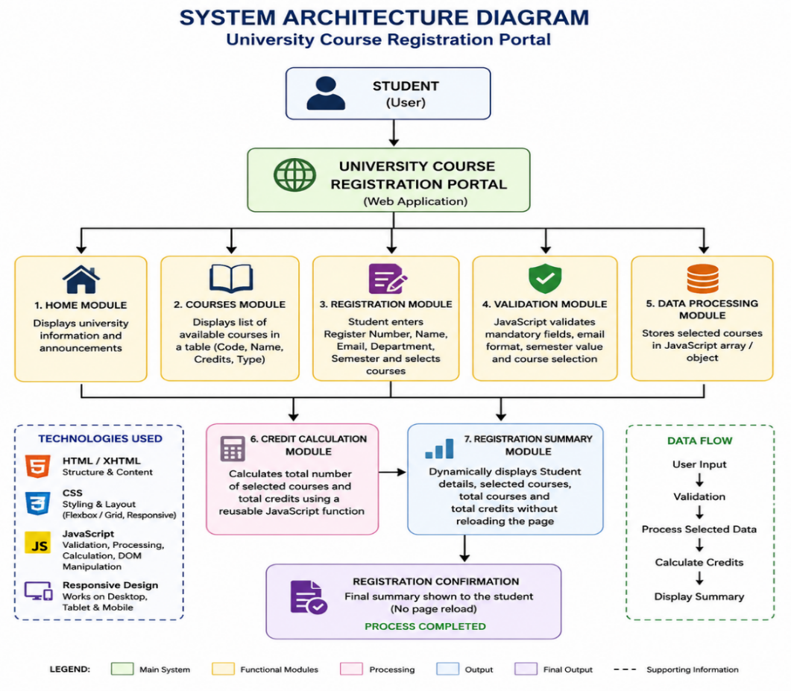

6. MODULE DESCRIPTION:
The course list is shown using an HTML table, since a table is the most natural way to present rows of structured data where every course has the same set of attributes (code, name, credits, type). A table also lines up the values in columns, which makes it easy for a student to compare credit values across courses at a glance, something that a plain list would not do as clearly.
Example courses are as follows:
Course Code | Course Name | Credits | Course Type
IT101 | Web Technologies | 4 | Core
IT102 | Java Programming | 4 | Core
IT103 | Database Management Systems | 3 | Core
IT104 | Computer Networks | 3 | Core
IT105 | Data Structures | 4 | Core

7. HTML/XHTML IMPLEMENTATION:
HTML/XHTML is used to create the basic structure and content of the Course Registration Portal.
- Header: Displays the university title, introduction, and purpose of the portal.
- Navigation: Provides internal hyperlinks to easily access Home, Courses, Registration, and Contact sections.
- Table: Displays available course details such as Course Code, Course Name, Credits, and Course Type in an organized format.
- Lists: Presents registration instructions and eligibility requirements clearly.
- Form: Collects student information and course selection using input fields, labels, dropdowns, checkboxes, and buttons.
- Footer: Provides university contact details, website information, and other relevant details.

8. CSS IMPLEMENTATION AND RESPONSIVE DESIGN:
CSS is used for creating a professional and attractive user interface.
CSS Selectors:
Various CSS selectors are used for styling HTML elements.
Some of them are the following:
- Element selectors
- Class selectors
- ID selectors
- Pseudo-class selectors
Pseudo-class selectors like hover are used for providing interactive effects.
Box Model:
The CSS box model is used to handle the spacing and sizing of webpage elements.
The main properties of the box model are:
- Content
- Padding
- Border
- Margin
These properties are used to set up the spacing between different sections and form elements.
Flexbox and Grid:
The Flexbox or CSS Grid technique is used to organize the webpage layout.
This makes it easier to align and arrange elements and build responsive layouts.
For example, the registration form can be organized using Grid, and navigation elements can be organized using Flexbox.
Hover Effects:
Hover effects are used for navigation links and buttons.
When the mouse pointer hovers over an element, the appearance of this element is changed.
This makes the portal more interactive.
Responsive Design:
The media queries are used to adapt the layout depending on the screen size.
On smaller screens:
- The navigation elements can be rearranged.
- The form fields can be shown in vertical orientation.
- The tables can become scrollable.
- The padding and font sizes can be adjusted.
Responsive design makes it possible to access the application from desktop computers, tablets, and mobile devices.

9. JAVASCRIPT IMPLEMENTATION:
JavaScript provides the interactive features of the Course Registration Portal.
The main JavaScript features used in the application are:
- Variables
- Functions
- Arrays
- Objects
- Conditional statements
- Loops
- Event handling
- DOM manipulation
- Form validation
Form Validation:
The JavaScript checks if the mandatory fields have valid values.
If any field has an invalid value, the registration is not processed.
This prevents the registration of students with incomplete information.
Arrays and Objects:
The selected courses are saved using arrays or objects.
This makes it possible to manage the selected courses efficiently.
Reusable Function:
The reusable JavaScript function is used to calculate:
- The total number of courses
- The total credits
This function can be called when the selected courses change.
Dynamic DOM Manipulation:
The JavaScript dynamically modifies the webpage content.
The registration summary is built and shown when the validation is successful.
It is not necessary to reload the complete webpage.
10. VALIDATION PROCESS:
The validation process makes sure that the information entered by the students is correct before the registration is accepted.
The validation steps are:
Step 1: Register Number Check
The register number field is checked if it is empty.
Step 2: Student Name Check
The student name is checked if it has been entered.
Step 3: Email Validation
The email is checked to be in a valid format.
Step 4: Department Check
The student has to choose a department.
Step 5: Semester Validation
The semester value is checked to be valid.
Step 6: Course Selection Check
The selected courses are checked.
Step 7: Registration Process
The selected course information is processed if the validation is successful.
Step 8: Credits Calculation
The total number of courses and total credits are calculated.
Step 9: Summary Display
The registration summary is dynamically shown.

11. TESTING AND DEBUGGING:
The testing is performed to validate the functionality of the Course Registration Portal.
Different input scenarios are tested.
Test Case | Input | Expected Result
Empty Register Number | Register Number not entered | Error message displayed
Empty Student Name | Name not entered | Error message displayed
Invalid Email | Incorrect email format | Validation error
Department Not Selected | No department selected | Error message
Invalid Semester | Incorrect semester value | Validation error
No Course Selected | No checkbox selected | Error message
Valid Registration | All valid details | Summary displayed
Multiple Courses | More than one course selected | Correct total credits

During the development process, the browser Developer Tools are used to find errors.
The browser console can be used to print JavaScript values.
For example, the selected course information can be printed using:
`console.log(selectedCourses);`
This makes it possible to check if the selected courses have been saved correctly.
The browser inspection tools can be used to find HTML and CSS errors.
An example error which may occur during the development process can be the incorrect calculation of total credits because the selected course value was not accessed correctly.
The error can be found by printing the selected course data in the browser console and then fixing the JavaScript logic.
After debugging, the system correctly calculates and shows the selected course information.
12. ADVANTAGES OF THE SYSTEM:
The Course Registration Portal offers benefits.
- Provides a simple and user-friendly interface.
- Displays course information in an organized manner.
- Provides easy navigation between webpage sections.
- Validates user input using JavaScript.
- Automatically calculates selected courses and total credits.
- Displays registration summary without page reload.
- Provides responsive design for different devices.
- Easy to maintain and update.
- Demonstrates practical use of HTML, CSS, and JavaScript.
This application can also act as a starting point for building an university management system.

13. FUTURE ENHANCEMENTS:
The current version of the application is a client-side prototype. There are features that can be added later.
Possible improvements include:
- Connect the system to a database for storing registrations.
- Add student login and authentication.
- Provide an administrator dashboard.
- Add course search, filtering, and credit-limit checking.
- Include prerequisites, timetable, and seat availability.
- Send registration confirmation through email.
- Generate PDF registration receipts.
- Allow students to modify or withdraw courses.
- Maintain registration history.

14. CONCLUSION:
The Interactive University Course Registration Portal was successfully developed using HTML/XHTML, CSS, and JavaScript. It provides university information, course details, navigation, registration instructions, and a student registration form.
HTML/XHTML creates the structure, CSS provides responsive and professional styling, and JavaScript handles validation, course processing, credit calculation, and dynamic registration summary. The project successfully demonstrates the practical application of web development concepts.

15.RESULT:
The University Course Registration Portal was successfully designed, implemented, and tested. Students can view courses, enter their details, select courses, and submit registration.
The system validates inputs, calculates the number of courses and total credits, and displays the registration summary dynamically without reloading the webpage. Thus, the application successfully meets the requirements of the proposed system.

16.OUTPUT IMAGES:

Output1: Home page
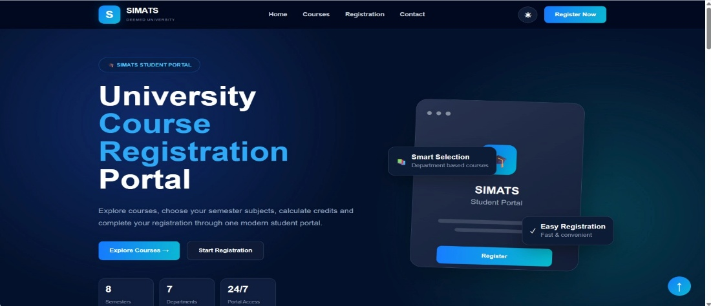

Output2: Courses using HTML Table
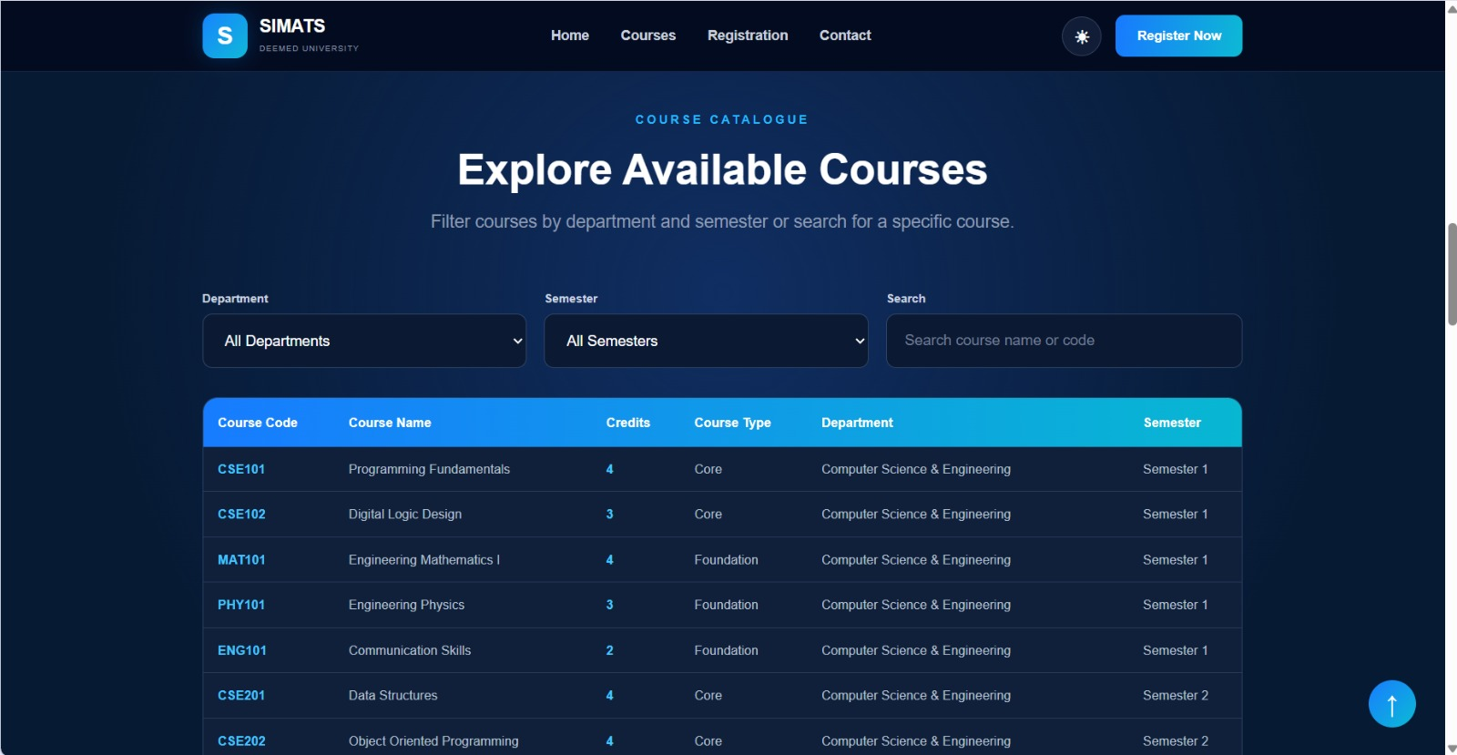

Output3: Registration Form


Output4:Contact details using Hyperlink